**Name : Shubham Garg**

**Enrollment No :9919103057**

**Batch : F2**

**VLab Experiment 1**

Resistivity by Four Probe Method

**AIM**

To determine the resistivity of semiconductors by Four probe Method.

## APPARATUS

The experimental set up consists of probe arrangement, sample , oven 0-200°C, constant current generator , oven power supply and digital panel meter(measuring voltage and current).

Four probe apparatus is one of the standard and most widely used apparatus for the measurement of resistivity of semiconductors.  
This method  is employed when the sample is in the form of a thin wafer, such as a thin semiconductor material deposited on a substrate. The sample is millimeter in size and having a thickness w. It consists of four probe arranged linearly in a straight line at equal distance S from each other. A constant current is passed through the two probes and the potential drop V across the middle two probes is measured. An oven is provided with a heater to heat the sample so that behavior of the sample is studied with increase in temperature.

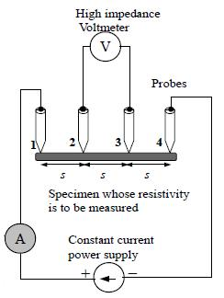       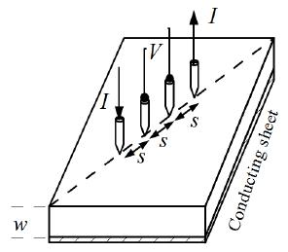

                                    Fig:1                                              Fig:2

The figure shows the arrangements of four probes that measure voltage (V) and supply current (A) to the surface of the crystal.

## THEORY

At a constant temperature, the resistance, R of a conductor is proportional to its length L and inversely proportional to its area of cross section A.

https://vlab.amrita.edu/userfiles/1/image/four%20probe/four1.JPG  (1)

Where ρ is the resistivity of the conductor and its unit is ohmmeter.

A semiconductor has electrical conductivity intermediate in magnitude between that of a conductor and insulator. Semiconductor differs from metals in their characteristic property of decreasing electrical resistivity with increasing temperature.

According to band theory, the energy levels of semiconductors can be grouped into two bands, valence band and the conduction band. In the presence of an external electric field it is electrons in the valence band that can move freely, thereby responsible for the electrical conductivity of semiconductors. In case of intrinsic semiconductors, the Fermi level lies in between the conduction band minimum and valence band maximum. Since conduction band lies above the Fermi level at 0K, when no thermal excitations are available, the conduction band remains unoccupied. So conduction is not possible at 0K, and resistance is infinite. As temperature increases, the occupancy of conduction band goes up, thereby resulting in decrease of electrical resistivity of semiconductor.

Resistivity of semiconductor by four probe method :  
1. The resistivity of material is uniform in the area of measurement.  
2. If there is a minority carrier injection into the semiconductor by the current- carrying electrodes most of the carriers recombine near electrodes so that their effect on conductivity is negligible.  
3. The surface on which the probes rest is flat with no surface leakage.  
4. The four probes used for resistivity measurement contact surface at points that lie in a straight line.  
5. The diameter of the contact between metallic probes and the semiconductor should be small compared to the distance between the probes.  
6. The boundary between the current carrying electrodes and the bulk material is hemispherical and small in diameter.  
7. The surface of semiconductor material may be either conducting and non-conducting. A conducting boundary is one on which material of much lower resistivity than semiconductor has been plated. A non-conducting boundary is produced when the surface of the semiconductor is in contact with insulator.  
Fig: 2 show the resistivity probes on a die of material. If the side boundaries are adequately far from the probes, the die may be considered to be identical to a slice. For this case of a slice of thickness w and the resistivity is computed as

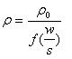   (2)

The function, f(w/S) is a divisor for computing resistivity which depends on the value of w and S  
We assume that the size of the metal tip is infinitesimal and sample thickness is greater than the distance between the probes,

https://vlab.amrita.edu/userfiles/1/image/four%20probe/four3.JPG      (3)

Where V – the potential difference between inner probes in volts.  
I – Current through the outer pair of probes in ampere.  
S – Spacing between the probes in meter.

**Temperature dependence of resistivity of semiconductor**

Total electrical conductivity of a semiconductor is the sum of the conductivities of the valence band and conduction band carriers. Resistivity is the reciprocal of conductivity and its temperature dependence is given by

https://vlab.amrita.edu/userfiles/1/image/four%20probe/four5.JPG     (4)

Where Eg – band gap of the material  
T – Temperature in kelvin  
K – Boltzmann constant, K – 8.6x10-5 eV/K  
The resistivity of a semiconductor rises exponentially on decreasing the temperature.

### Applications

1. Remote sensing areas  
2. Resistance thermometers  
3. Induction hardening process  
4. Accurate geometry factor estimation  
5. Characterization of fuel cells bipolar plates

## Procedure for Simulation

### Combo Box and Sliders

* **Select Material**- This is used to select semiconductor material for doing the simulator.

* **Range of Current** - One can choose the range of current for the current source.

* **Current’ Slider** - It ranges from 1mA to 200mA. (Note:The divisions in the slider is fixed as 100). If 20mA current is selected in the combo      box, the slider value will range from 0mA to 20mA, with an interval of 0.2mA and if the value is 200mA in the combo box, slider value changes from 0mA to 200mA with an interval of 2mA.

* **Range of oven** - This combo box is used to fix the temeprature to a particular range.

* **Oven**-  Oven is used to vary the temeprature upto 2000 C.

                Set Button – It is used to fix the temperature in the oven.

     Run Button – After setting the temperature, using run button we can start heating the

Oven.

                Wait Button – It is used to stop heating the oven at a particular temperature.

                Measure Button- It is used to display the present temperature of the oven.

* **Select Range Combo Box**– Options are X1 and X10.

* **Temperature slider**- it ranges from 270C to 2000 C. active only by clicking the Set button and become inactive after clicking Run button. If X1 is in combo box, the slider value ranges from 270 C to 990 C and If the value is X10 in combo box, slider value changes from 2.7 0 C to 200 C.

* **Voltmeter Combo Box** - Options are 1 mV, 10 mV, 100 mV, 1 V, 10 V.  One can select it for getting output in a particular range.

### Procedure

1. Select the semiconductor material from the combo box.

2. Select the source current from the slider. Restrict the slider based on the range of current.

3. Select the Range of oven from the combo box.

4. Set the temperature from the slider.

5. Click on the Run Button to start heating the oven in a particular interval, from the default 250C to the temperature that we set already Click on the Wait button to stop heating.

6. Click on the Set button to display the temperature that we set in the oven.

7. Click on the Measure button to display the present temperature in the oven.

8. Select the range of voltmeter from the combo box.

9. Measure the Voltage using Voltmeter.

10.Calculate the Resistivity of semiconductor in eV for the given temperature using equation (2) and (3).

11. A Graph is plotted with Temperature along x-axis and resistivity of semiconductor along y-axis.

## Observations Table

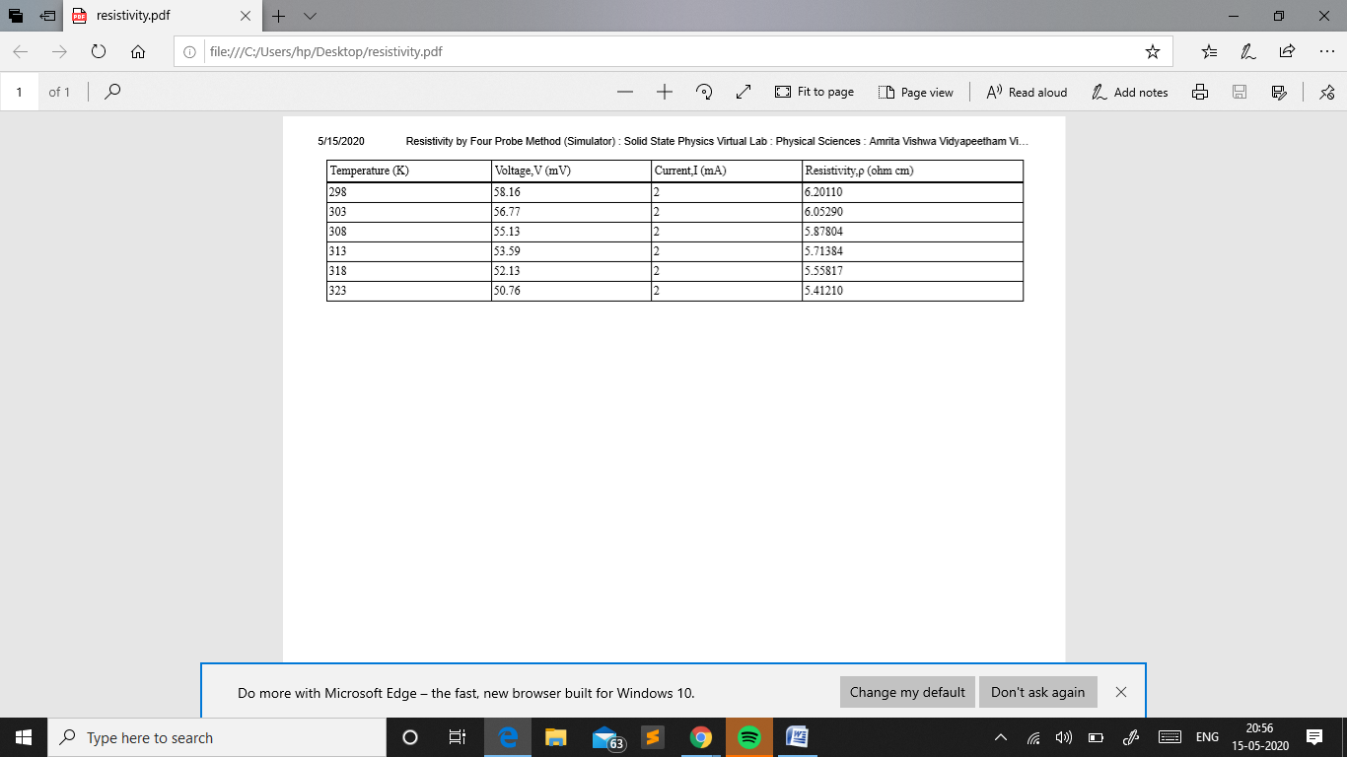

**Graph**

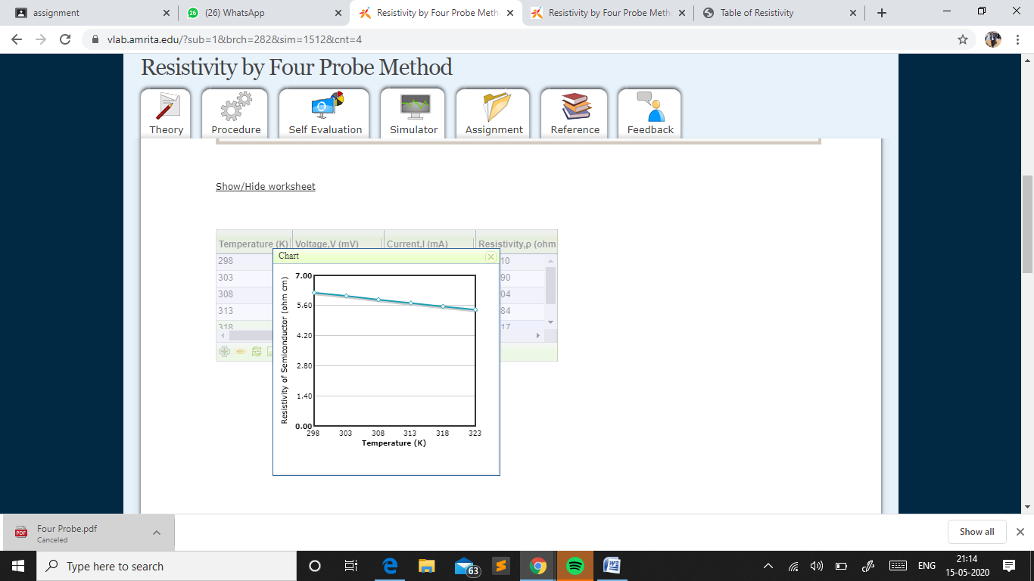

**Screenshots**

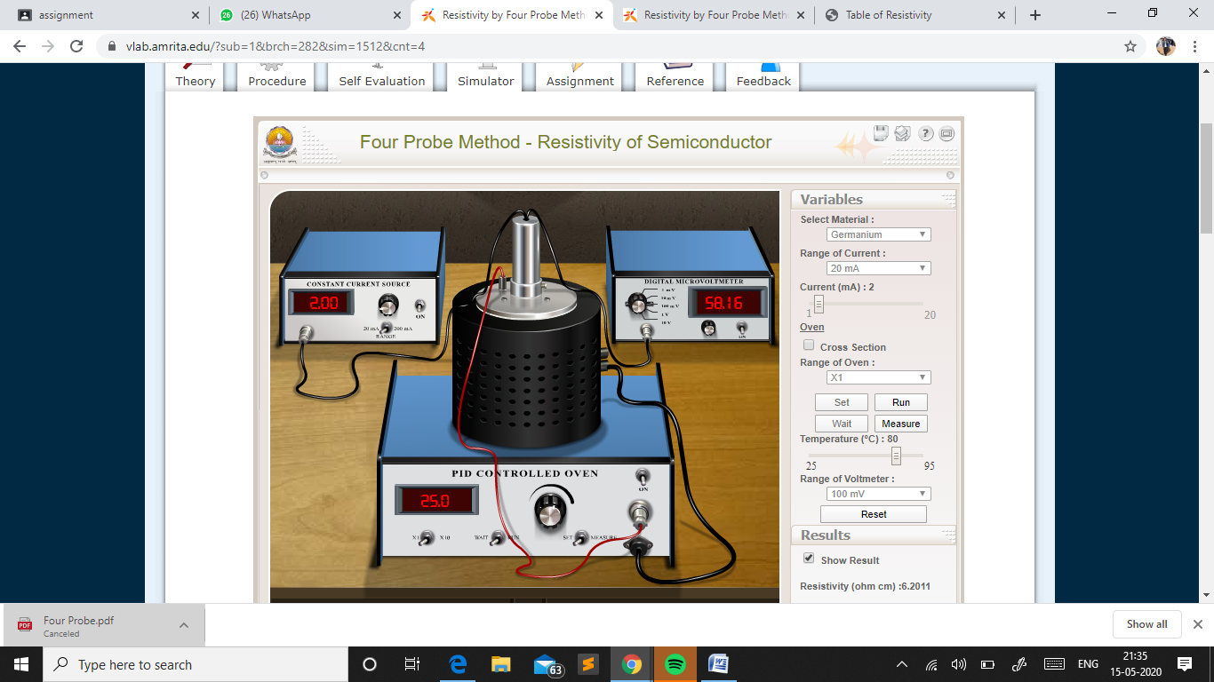

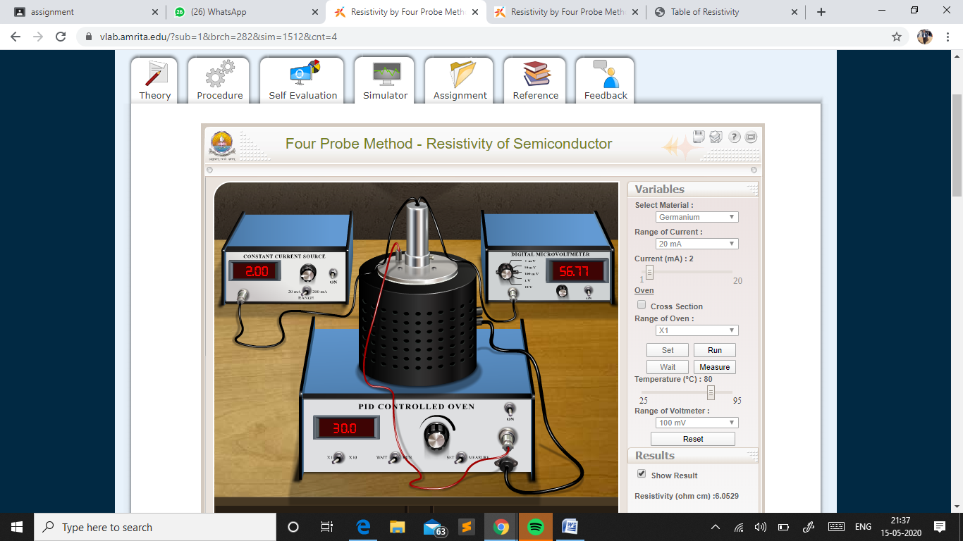

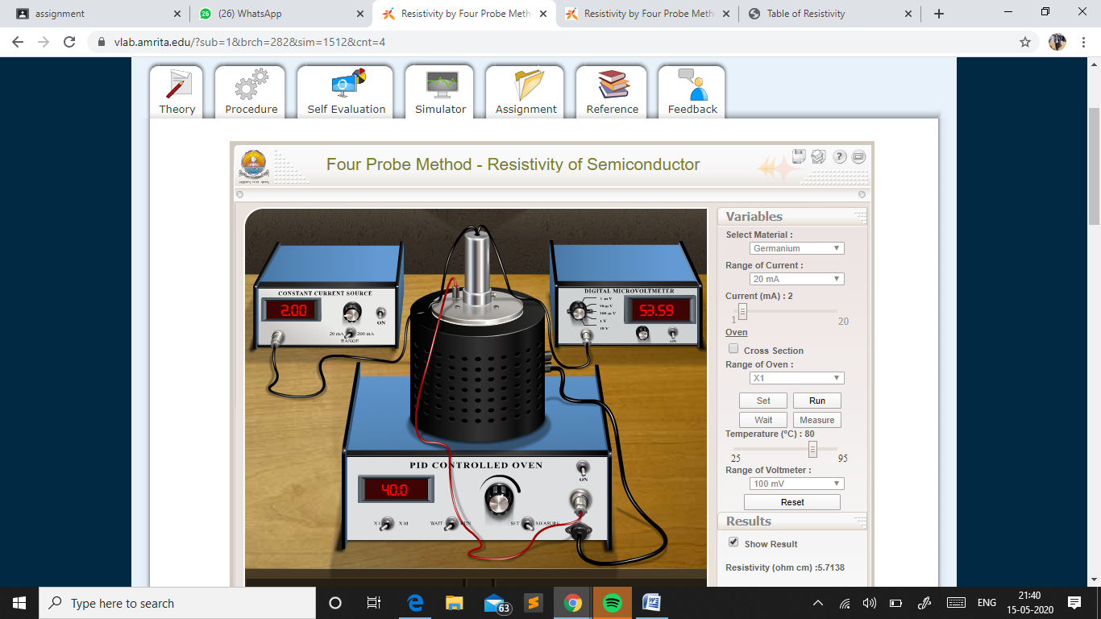

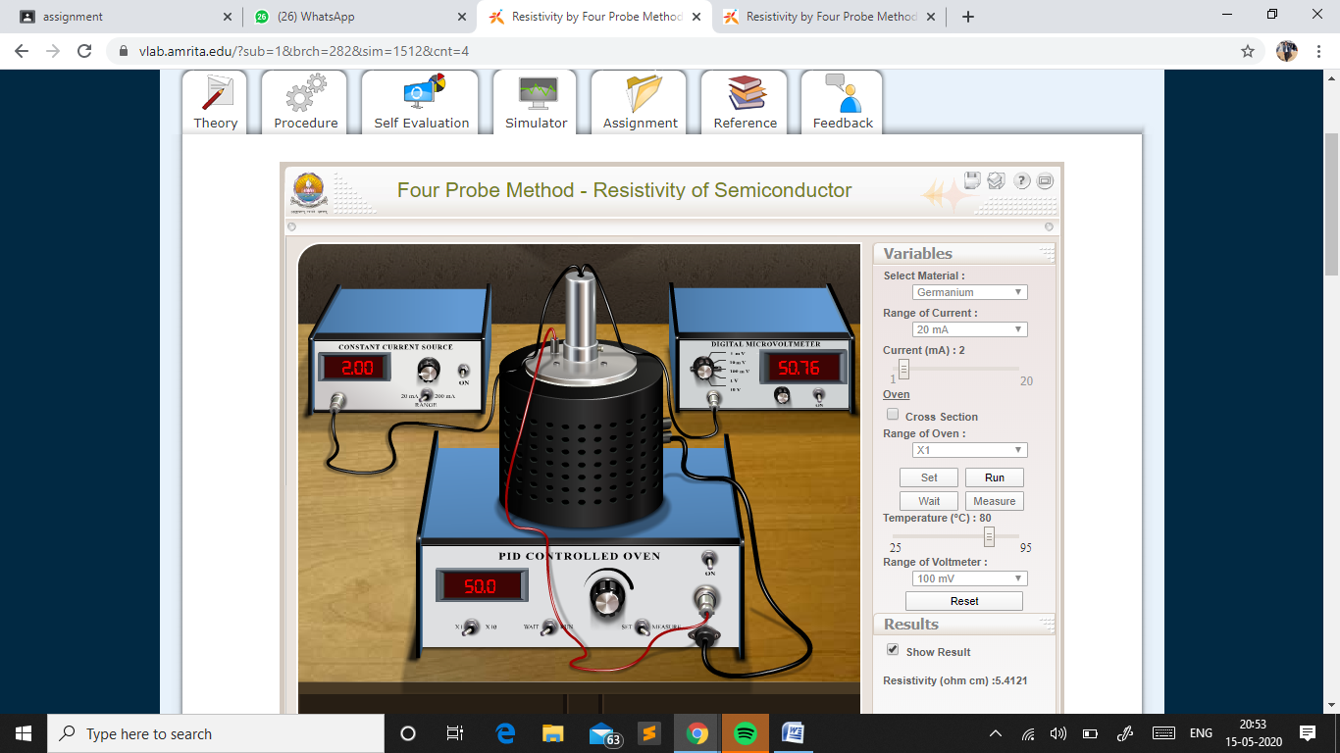

### Calculations

 Resistivity can be calculated by using the equation given below.

Here we take,

Distance between the probes, S = **0.2cm**

Thickness of the sample,w = **0.05cm**.

From standard table f(w/S) = **5.89**



### 

### Result

 The **Resistivity** of the **Germanium** semiconductor by **Four probe Method** =  **5.802 Ω cm**

**Virtual Lab Experiment 2**

Crystal Structure

**Aim**

To study various crystals structures.

**Theory**

Matter exist usually in solid or fluid (liquid, gas) state. According to modern concept matter classification is specified as condensed state and gaseous state. Solids and liquids come under condensed state. Any material whose position of constituent particles is fixed can be regarded as solids.

Solids are characterized by incompressibility, rigidity and mechanical strength. This indicates that the molecules, atoms or ions that make up as solid is closely packed. Thus in solids we will have a well ordered molecular, atomic or ionic arrangement.

In general solids can be classified into:

* Crystalline-particles are orderly arranged (long range order).
* Amorphous-particles are randomly oriented.

If the atoms or molecules are uniquely arranged in crystalline solid or liquid we call it as a crystal structure. A crystal posses long range order and symmetry. The main property of crystal structure is its periodicity. This periodicity is due to the arrangement of atoms/molecules in the lattice points. The crystal structure as a whole can be considered as the repetition of unit cell. For a given crystal structure the shape of unit cell is same but varies from crystal to crystal.

X-ray diffraction studies reveal that the constituent particles (molecules, atoms or ions) are arranged in a definite pattern in the crystal. To get the diffraction pattern the wavelength of light used must be comparable with the atomic spacing.

**Lattice**

A crystal structure is formed only when the group of atoms is arranged identically at the lattice point. The group of atoms or molecules is called a basis. Lattice point is actually an imaginary concept.

In other way, we can say that,

Lattice + Basis=crystal structure

Line joining any two points is a translation in lattice. Two non-collinear translation leads to a plane lattice and three non coplanar translation leads to a space lattice.

**Unit cell**

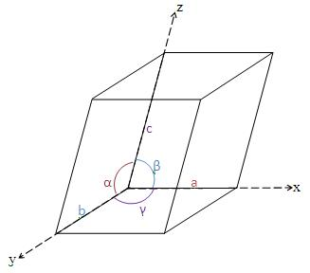Unitcell can be considered as the building block of a crystal. It has the same symmetry as the entire crystal. When we arrange the unit cell in 3D , we get the bulk crystal. In other words it can be described as the smallest volume which when repeated in all direction gives the crystal. The three edges a, b, c along the axis and angle Between them α, β and γ is termed as lattice parameters. In 3D it is better to consider a parallelepiped as unit cell.

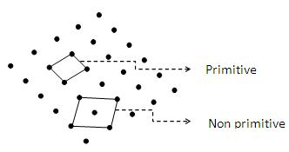

Unit cell can be of primitive as well as non primitive type. A primitive cell is a minimum volume unit cell and has only one lattice point in it and the latter contains more than one.

In the given figure below, simple cube is a primitive cell. No.of atoms per unit cell is one for it. The rest two is non primitive. No.of atoms per unit cell is 2 and 4 respectively.

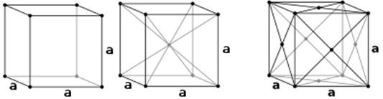

       Simple cubic (P)      Body- centred cubic (I)        Face centered cubic (F)

**Bravais Lattice in Two dimension-Plane lattice**

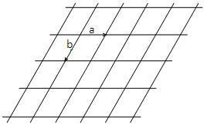In general, number of lattices obtained is unlimited since there is no restriction to the length a, b of the lattice translations and on angle φ between them. Such a lattice for arbitrary a, b and φ is known as oblique lattice. This oblique lattice is invariant under rotation of 2π/n (with n=1 and 2). It can also be made invariant under rotation of 2π/n with n=3, 4 and 6.

For a=b and φ=900, we get square lattice  
a≠b and φ=900, rectangular a=b and φ=φ0,rhombus a=b and φ=600, hexagonal

**Bravais Lattice in Three dimension-Space lattice**

Based on the lattice parameters a, b, c, α, β and γ and applying the restrictions as above, only 14 types of lattices are possible in three dimensions. One general (triclinic) and thirteen special. Only seven different systems of axis are found to be sufficient to represent all Bravais lattice. This fourteen space lattice is divided into seven crystal systems.

They are triclinic, monoclinic, orthorhombic, tetragonal, trigonal, hexagonal and cubic.

|  |  |  |  |  |  |  |
| --- | --- | --- | --- | --- | --- | --- |
| **Serial No:** | **Lattice Systems** | **Simple** | **Base-centered** | **Body-centered** | **Face-centered** | **Example** |
| 1 | triclinic(none) | https://vlab.amrita.edu/userfiles/image2%2827%29.jpg |  |  |  | CuSO4.5H2O, K2Cr2O7 |
| 2 | monoclinic(1diad) | https://vlab.amrita.edu/userfiles/image3%2814%29.jpg | https://vlab.amrita.edu/userfiles/image4%2812%29.jpg |  |  | CaSO4.2H2O, FeSO4, Na2SO4 |
| 3 | orthorhombic(3 perpendicular diads) | https://vlab.amrita.edu/userfiles/image5%2823%29.jpg | https://vlab.amrita.edu/userfiles/image6%2815%29.jpg | https://vlab.amrita.edu/userfiles/image7%2812%29.jpg | https://vlab.amrita.edu/userfiles/image8%2815%29.jpg | KNO3, BaSO4 |
| 4 | rhombohedral(1 triad) | https://vlab.amrita.edu/userfiles/image9%2811%29.jpg |  |  |  | As, Sb, Bi |
| 5 | tetragonal(1 tetrad) | https://vlab.amrita.edu/userfiles/image10%2812%29.jpg |  | https://vlab.amrita.edu/userfiles/image11%2810%29.jpg |  | TiO2, SnO2, NiSO4 |
| 6 | hexagonal(1 hexad) | https://vlab.amrita.edu/userfiles/image12%287%29.jpg |  |  |  | SiO2, Zn, Mg, Cd |
| 7 | cubic(4 triads) | https://vlab.amrita.edu/userfiles/image13%285%29.jpg |  | https://vlab.amrita.edu/userfiles/image14%284%29.jpg | https://vlab.amrita.edu/userfiles/image15%284%29.jpg | Au, Cu, NaCl |

**Atomic packing Fraction (APF)**

Atomic packing fraction mainly gives us an idea about the arrangement of atoms/ions in solids. It will give the efficiency with which the available space is being filled by atoms.

Packing fraction is defined as the ratio of volume of atoms occupying the unit cell to the volume of unit cell.

«math xmlns=¨http://www.w3.org/1998/Math/MathML¨»«mi»A«/mi»«mi»P«/mi»«mi»F«/mi»«mo»=«/mo»«mfrac»«mrow»«mi»V«/mi»«mi»o«/mi»«mi»l«/mi»«mi»u«/mi»«mi»m«/mi»«mi»e«/mi»«mo»§nbsp;«/mo»«mi»o«/mi»«mi»f«/mi»«mo»§nbsp;«/mo»«mi»a«/mi»«mi»t«/mi»«mi»o«/mi»«mi»m«/mi»«mi»s«/mi»«mo»§nbsp;«/mo»«mi»i«/mi»«mi»n«/mi»«mo»§nbsp;«/mo»«mi»u«/mi»«mi»n«/mi»«mi»i«/mi»«mi»t«/mi»«mo»§nbsp;«/mo»«mi»c«/mi»«mi»e«/mi»«mi»l«/mi»«mi»l«/mi»«/mrow»«mrow»«mi»V«/mi»«mi»o«/mi»«mi»l«/mi»«mi»u«/mi»«mi»m«/mi»«mi»e«/mi»«mo»§nbsp;«/mo»«mi»o«/mi»«mi»f«/mi»«mo»§nbsp;«/mo»«mi»u«/mi»«mi»n«/mi»«mi»i«/mi»«mi»t«/mi»«mo»§nbsp;«/mo»«mi»c«/mi»«mi»e«/mi»«mi»l«/mi»«mi»l«/mi»«/mrow»«/mfrac»«/math»

Examples:

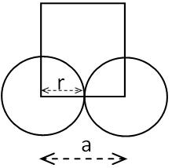**1.    Simple Cubic**

Consider a cube of side 'a' .Atoms of radius ‘r’ is placed at the corner. So that length of cube a=2r.  
**Volume of atoms in unit cell**

«math xmlns=¨http://www.w3.org/1998/Math/MathML¨»«mo»=«/mo»«mfrac»«mrow»«mn»1«/mn»«mo»*«/mo»«mn»4«/mn»«mi»§#960;«/mi»«msup»«mi»r«/mi»«mn»3«/mn»«/msup»«/mrow»«mn»3«/mn»«/mfrac»«/math»  
  
In a simple cubic structure, the atoms occupies at the eight corners. An atom at the corner is equally shared by 8 unit cells. So the contribution of one atom to a unit cell is 1/8. Therefore the no. of atoms per unit cell is (1/8)*8(corner atoms) =1.

Volume of unit cell=«math xmlns=¨http://www.w3.org/1998/Math/MathML¨»«msup»«mi»a«/mi»«mn»3«/mn»«/msup»«mo»=«/mo»«mo»(«/mo»«mn»2«/mn»«mi»r«/mi»«msup»«mo»)«/mo»«mn»3«/mn»«/msup»«mo»=«/mo»«mn»8«/mn»«msup»«mi»r«/mi»«mn»3«/mn»«/msup»«/math»

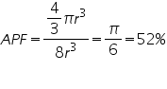

**2.    Body centered Cube**

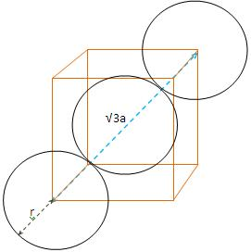

Consider a cube of side ‘a’, and atoms of radius ‘r’ are placed at corners and at the body centre. Length of body diagonal, √3a=4r.

**Volume of atoms in unit cell**

«math xmlns=¨http://www.w3.org/1998/Math/MathML¨»«mo»=«/mo»«mfrac»«mrow»«mn»2«/mn»«mo»*«/mo»«mn»4«/mn»«mi»§#960;«/mi»«msup»«mi»r«/mi»«mn»3«/mn»«/msup»«/mrow»«mn»3«/mn»«/mfrac»«mo»=«/mo»«mfrac»«mrow»«mn»8«/mn»«mi»§#960;«/mi»«msup»«mi»r«/mi»«mn»3«/mn»«/msup»«/mrow»«mn»3«/mn»«/mfrac»«/math»

In a body centered cube, there will be one atom at the centre along with 8 corner atoms. This corner atom is shared by 8 unit cell and the atom at the centre is not a shared one. Therefore no. of atoms per unit cell= (1/8)*8(corner atoms)+1(body centre)=2.

**Volume of unit cell**

«math xmlns=¨http://www.w3.org/1998/Math/MathML¨»«mo»=«/mo»«msup»«mi»a«/mi»«mn»3«/mn»«/msup»«mo»=«/mo»«mo»(«/mo»«mfrac»«mrow»«mn»4«/mn»«mi»r«/mi»«/mrow»«msqrt»«mn»3«/mn»«/msqrt»«/mfrac»«msup»«mo»)«/mo»«mn»3«/mn»«/msup»«/math»

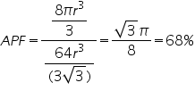

**3.    Face centered Cube**

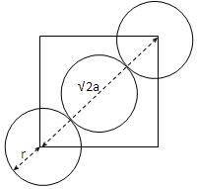

Consider a cube of length ‘a’ and atoms of radius ’r’ are placed at the corners as well as at the face centre. Length of face diagonal √2a=4r.  
Volume of unit cell«math xmlns=¨http://www.w3.org/1998/Math/MathML¨»«mo»=«/mo»«mfrac»«mrow»«mn»4«/mn»«mo»*«/mo»«mn»4«/mn»«/mrow»«mn»3«/mn»«/mfrac»«mi»§#960;«/mi»«msup»«mi»r«/mi»«mn»3«/mn»«/msup»«mo»=«/mo»«mfrac»«mn»16«/mn»«mn»3«/mn»«/mfrac»«mi»§#960;«/mi»«msup»«mi»r«/mi»«mn»3«/mn»«/msup»«/math»

In a face centered cube, each face possess one atom along with 8 corner atoms. The atoms at the faces are equally shared by two unit cell. Corner atoms by 8 unit cells. So the no. of atoms per unit cell is=(1/8)*8(corner atoms)+(1/2)*6(atoms at face)=4.

**Volume of unit cell**

«math xmlns=¨http://www.w3.org/1998/Math/MathML¨»«mo»=«/mo»«msup»«mi»a«/mi»«mn»3«/mn»«/msup»«mo»=«/mo»«mo»(«/mo»«mfrac»«mrow»«mn»4«/mn»«mi»r«/mi»«/mrow»«msqrt»«mn»2«/mn»«/msqrt»«/mfrac»«msup»«mo»)«/mo»«mn»3«/mn»«/msup»«/math»

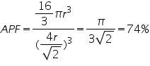

## Procedure for doing simulation

 1.  Select crystal lattice type from Lattice Type combo box.

 2.  Choose the corresponding crystal lattice sub type from Sub Type combo box.

 3.  Adjust the crystal lattice transparency by using the Lattice Transparency slider.

 4.  For viewing the angles and sides, click and drag the crystal lattice so as to rotate it.

**Screenshots**

**TRICLINIC**

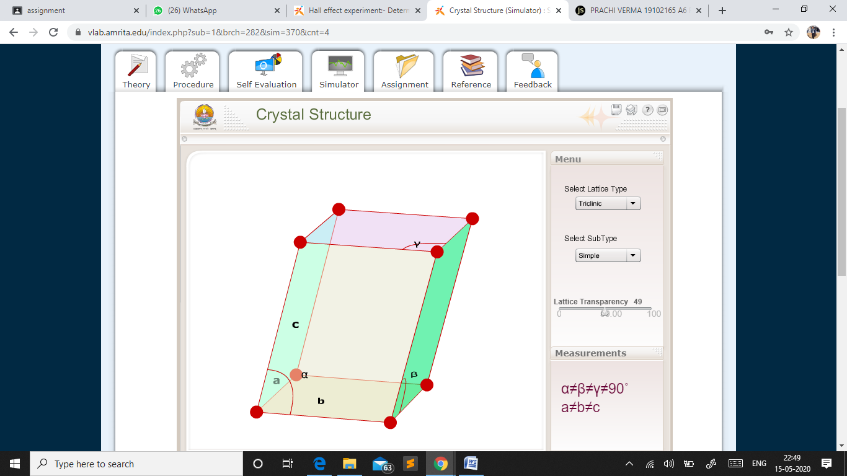

**MONOCLINIC : Simple**

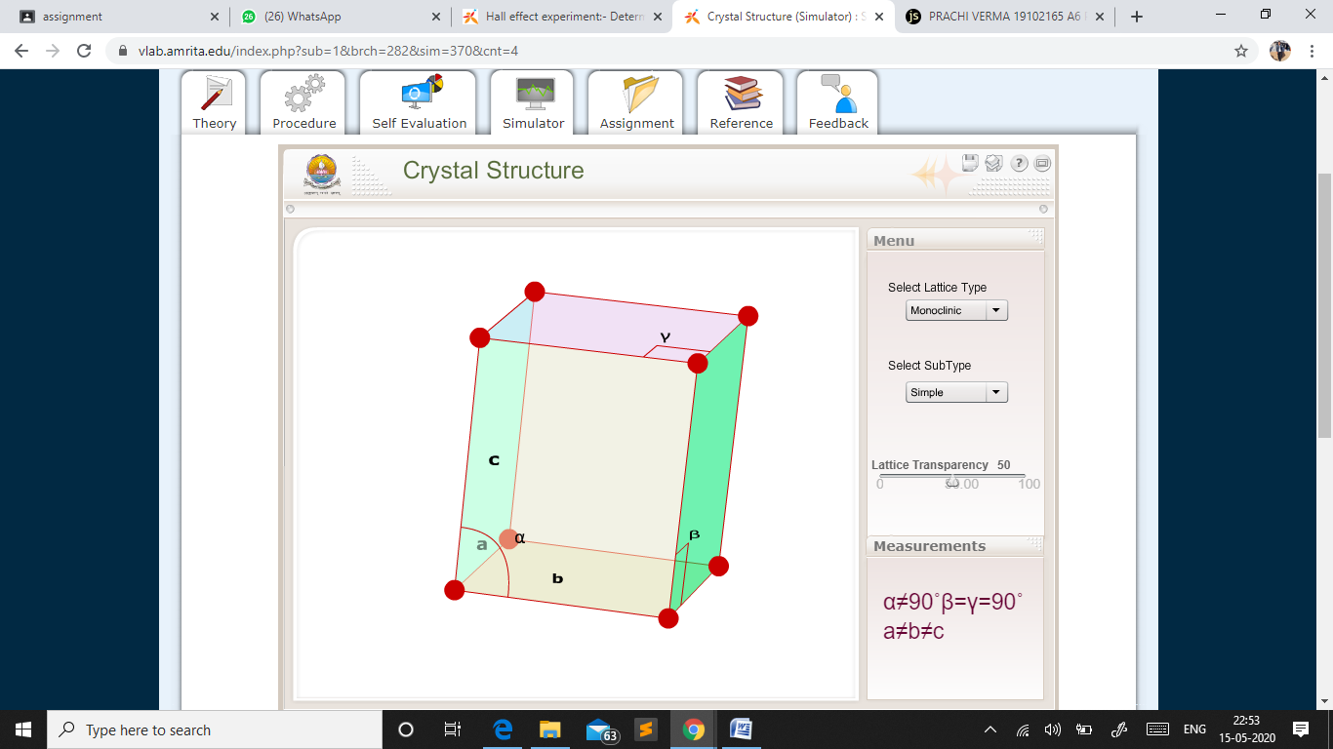

**MONOCLINIC : Base Centered**

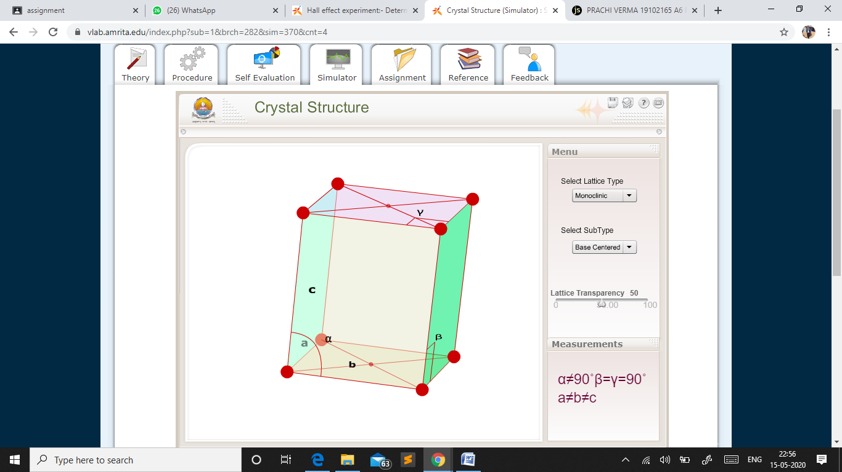

**ORTHORHOMBIC : Simple**

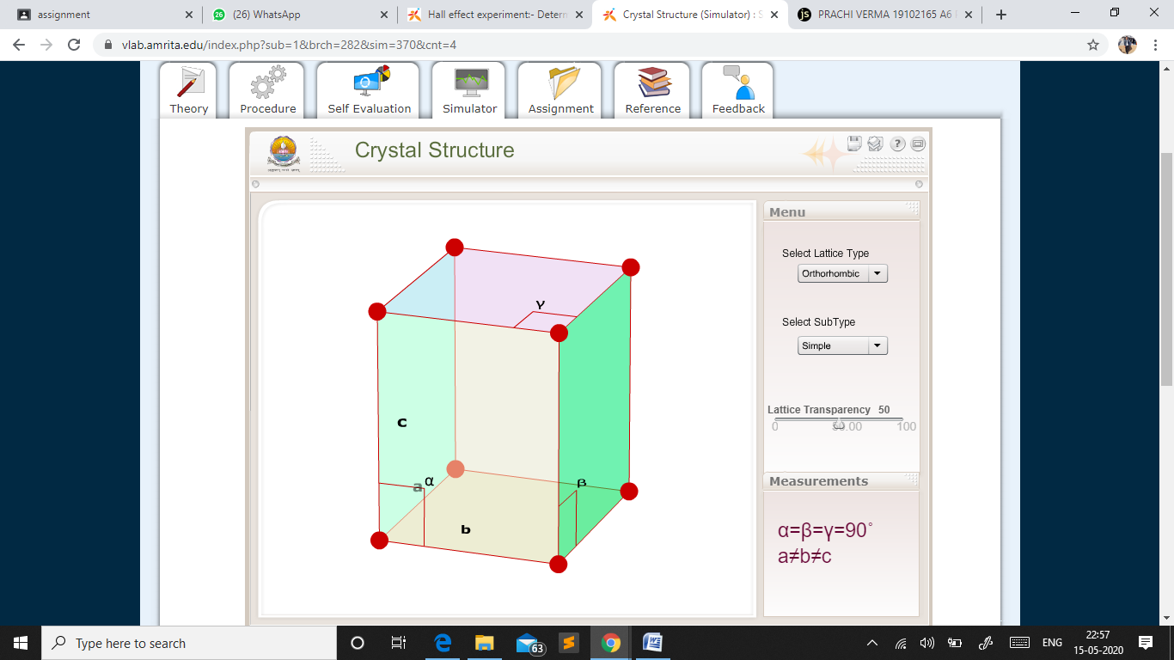

**ORTHORHOMBIC : Base Centered**

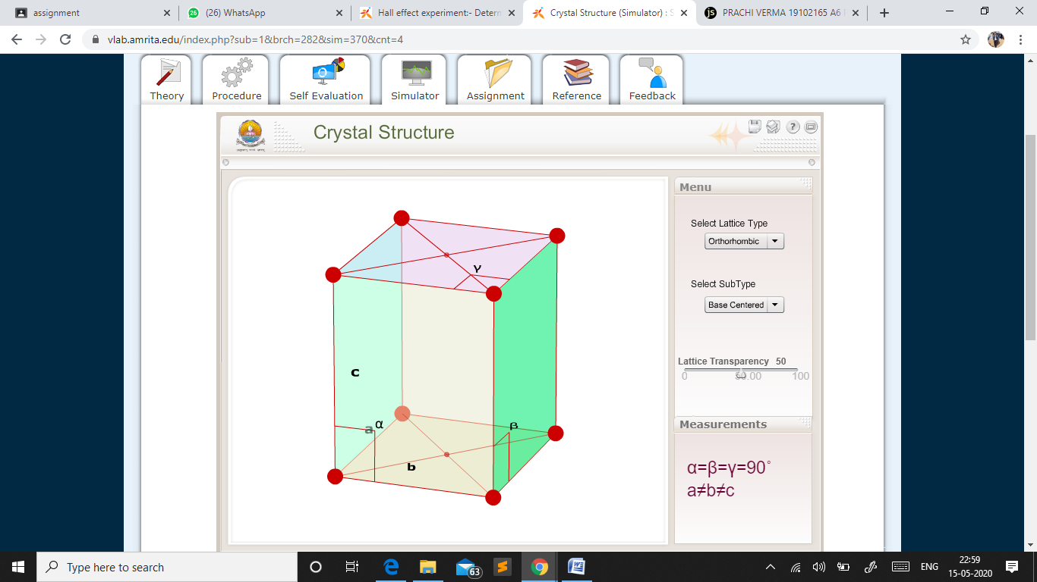

**ORTHORHOMBIC : Body Centered**

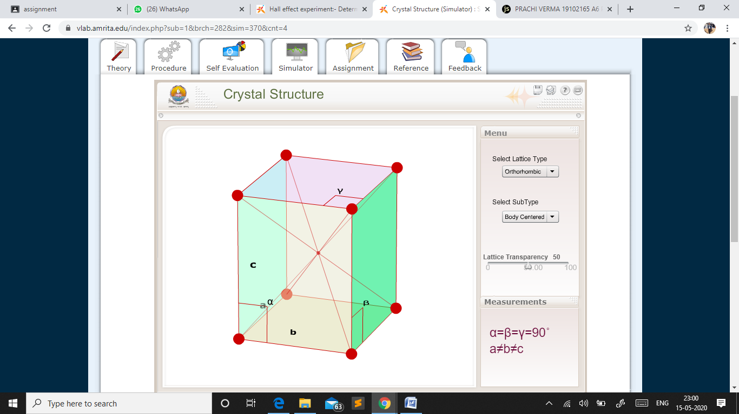

**ORTHORHOMBIC : Face Centered**

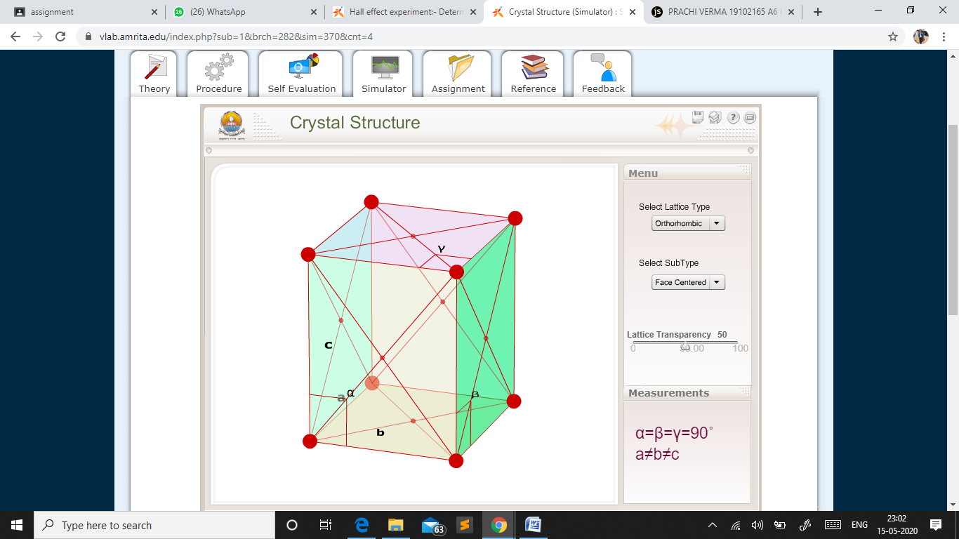

**RHOMBOHEDRAL : Simple**

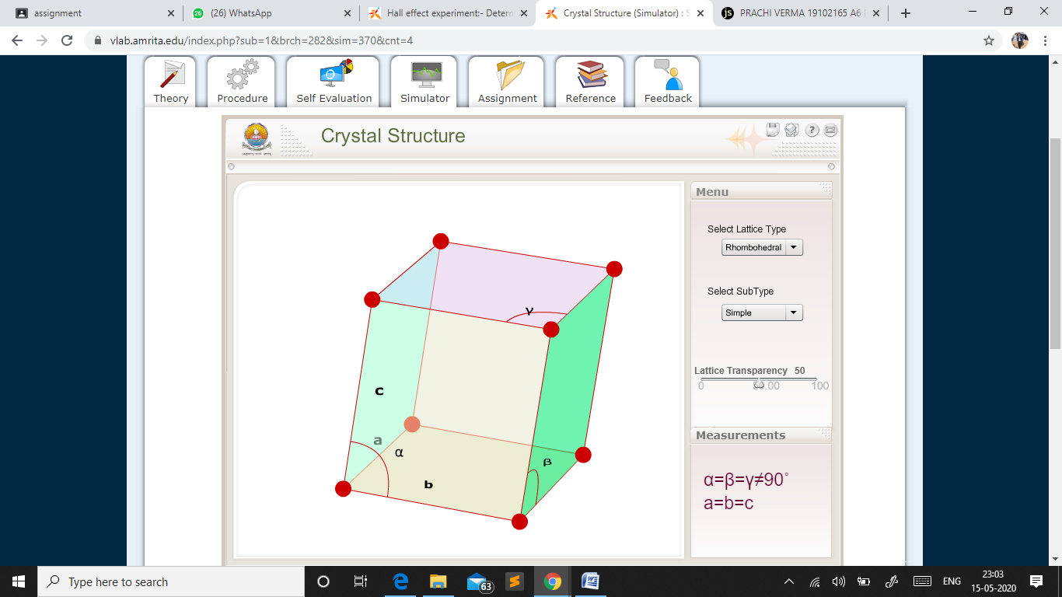

**TETRAGONAL : Simple**

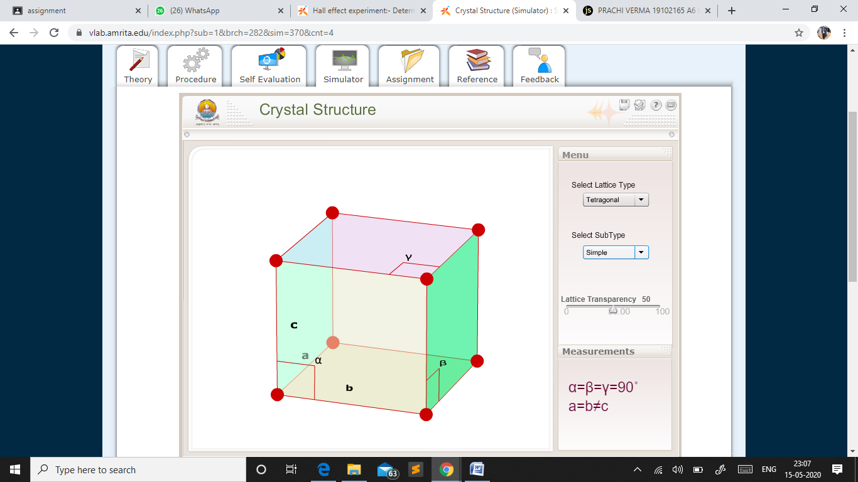

**TETRAGONAL : Body Centered**

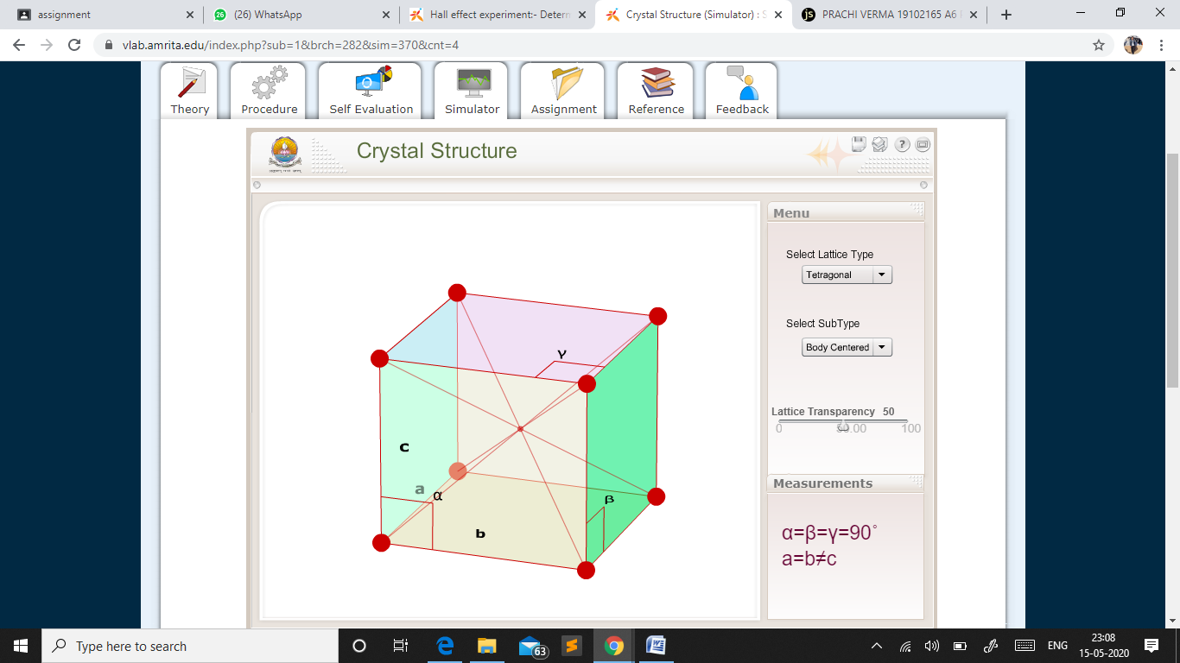

**HEXAGONAL : Simple**

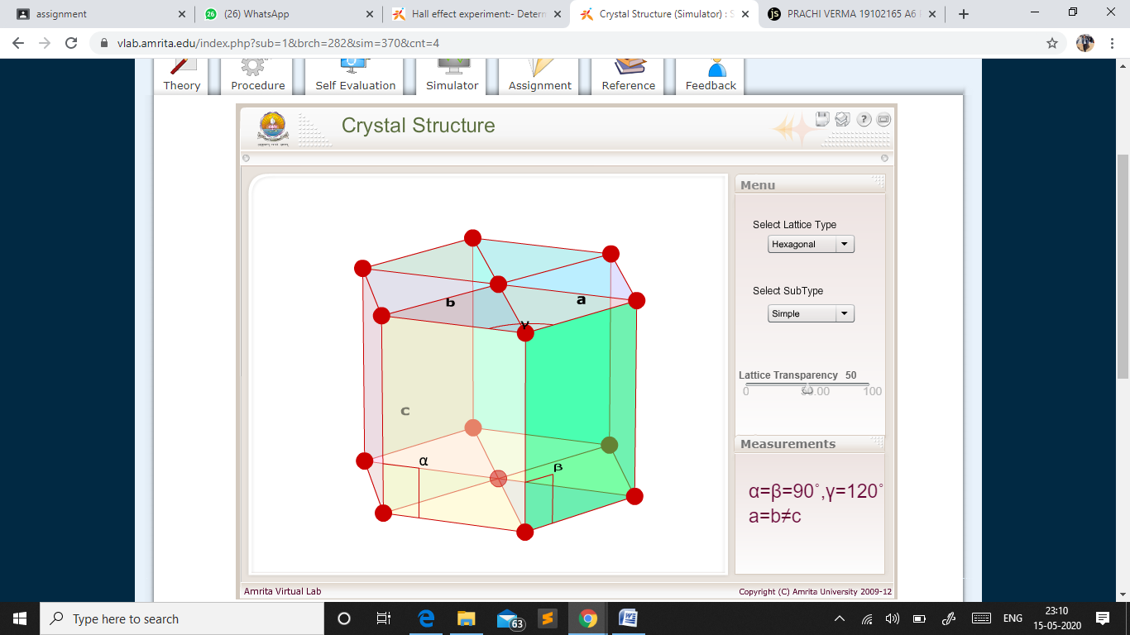

**CUBIC : Simple**

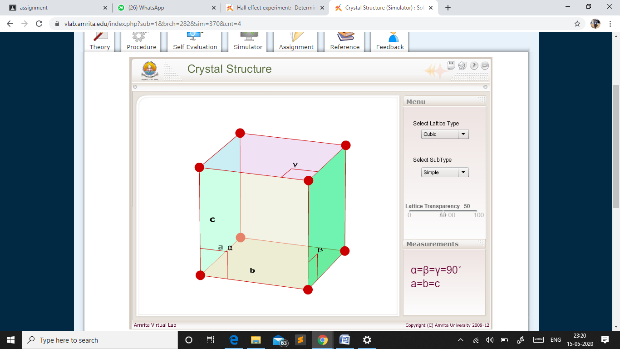

**CUBIC : Body Centered**

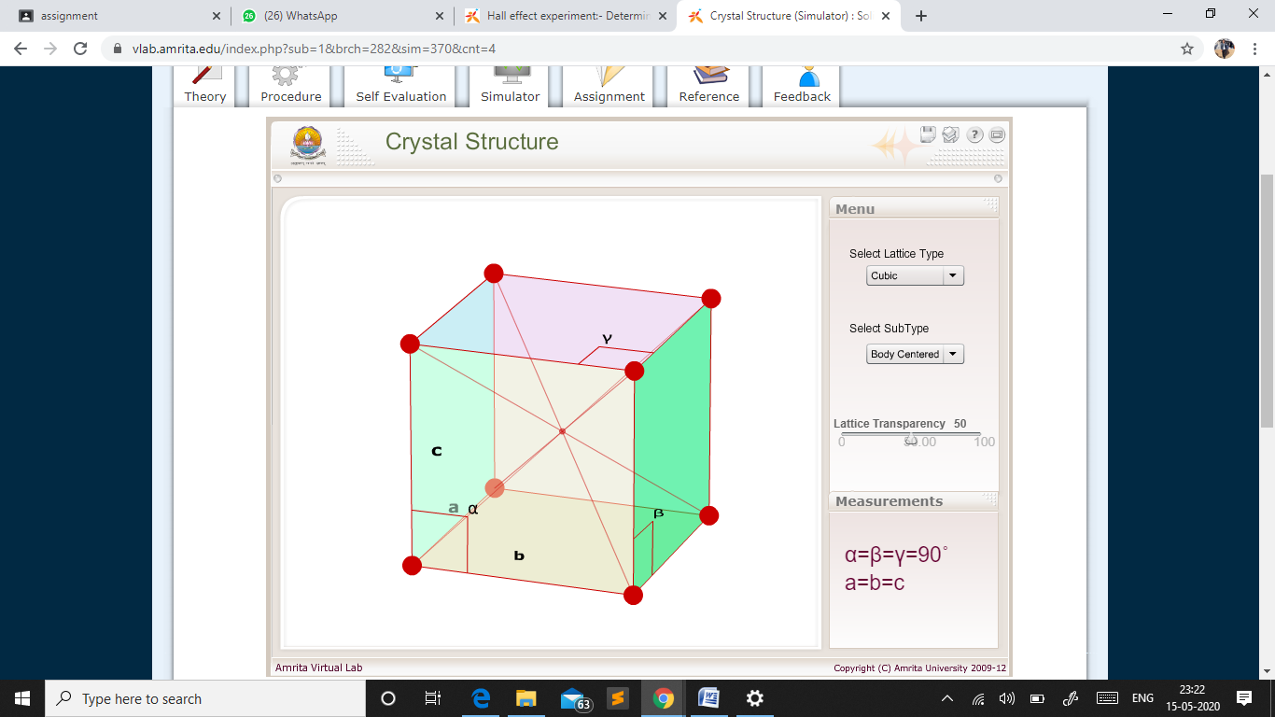

**CUBIC : Face Centered**

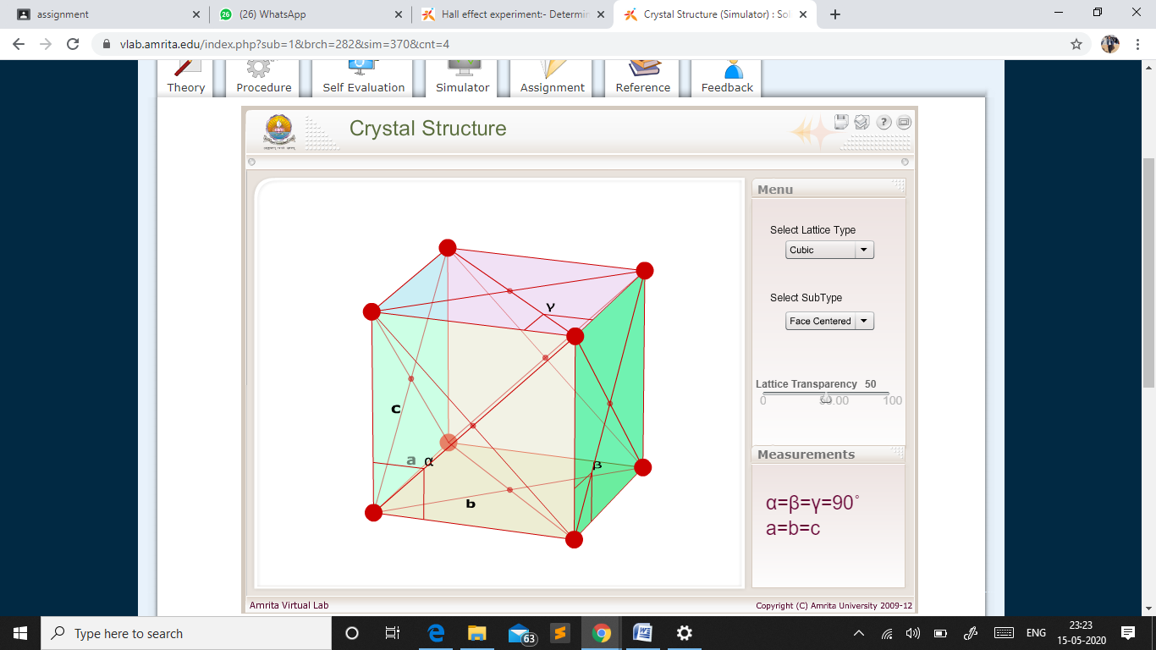

**Result**

The various Crystal Structure studied.

**VLab Experiment 3**

Numerical Aperture of Optical Fiber

**Aim**

To find the numerical aperture of a given optic fibre and hence to find its acceptance angle.

**Theory**

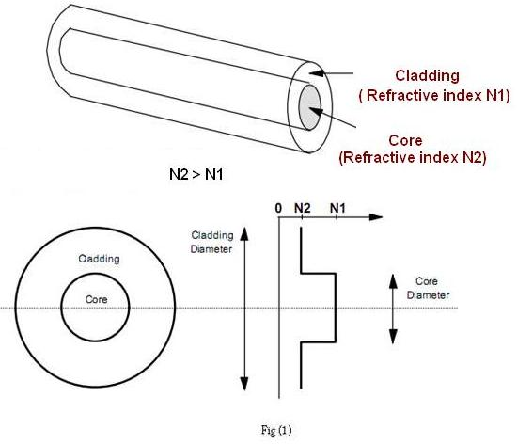Optical fibers are fine transparent glass or plastic fibers which can propagate light. They work under the principle of total internal reflection from diametrically opposite walls. In this way light can be taken anywhere because fibers have enough flexibility. This  property makes them suitable for data communication, design of fine endoscopes, micro sized microscopes etc. An optic fiber  consists of a core that is surrounded by a cladding  which are normally made of silica glass or plastic. The core  transmits an optical signal while the  cladding  guides the light within the core. Since  light is guided through the fiber it is sometimes called an optical wave guide. The basic construction of an optic fiber is shown in figure (1).

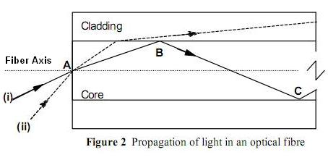In order to understand the propagation of light through an optical fibre, consider the figure (2). Consider a light ray (i) entering the core at a point A , travelling through the core until it reaches the core cladding boundary at point B. As long as the light ray intersects the core-cladding boundary at a small  angles, the ray will be reflected back in to the core to travel on to point C where the process of reflection is repeated .ie., total internal reflection takes place. Total internal reflection occurs only when the angle of incidence is greater than the critical angle.  If a ray enters an optic fiber at a steep angle(ii), when this ray intersects the core-cladding boundary, the angle of intersection is too large. So, reflection back in to the core does not take place and the light ray is lost in the cladding. This means that to be guided through an optic fibre, a light ray must enter the core with an angle less than a particular angle called the acceptance angle of the fibre. A ray which enters the fiber with an angle greater than the acceptance angle will be lost in the cladding.

Consider an optical fibre having a core  of refractive index n1 and cladding of refractive index n2. let the incident light makes an angle i with the core axis as shown in figure (3). Then the light gets refracted at an angle θ and fall on the core-cladding interface at an angle where,

https://vlab.amrita.edu/userfiles/image026%20%282%29.png  -----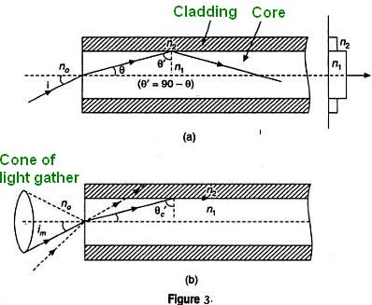----------------- (1)

By Snell’s law at the point of entrance of light in to the optical fiber we get,

https://vlab.amrita.edu/userfiles/image025%20%281%29%283%29.png   -------------------- (2)

Where n0is refractive index of medium outside the fiber. For air n0 =1.

When light travels from core to cladding it moves from denser to rarer medium and so it may be totally reflected back to the core medium if θ' exceeds the critical angle θ'c. The critical angle is that angle of incidence in denser medium (n1) for which angle of refraction become 90°. Using Snell’s laws at core cladding interface,

https://vlab.amrita.edu/userfiles/image040%20%281%29.png

                                             or

https://vlab.amrita.edu/userfiles/image055%20%281%29%281%29.png   ----------------------- (3)

Therefore, for light to be propagated within the core of optical fiber as guided wave, the angle of incidence at core-cladding interface should be greater than θ'c. As i increases,  θ increases and so θ' decreases. Therefore, there is maximum value of angle of incidence beyond which, it does not propagate rather it is refracted in to cladding medium ( fig: 3(b)). This maximum value of i say im is called maximum angle of acceptance and  n0 sin im is termed as the numerical aperture (NA).

From equation(2),

https://vlab.amrita.edu/userfiles/image046%20%281%29.png

https://vlab.amrita.edu/userfiles/image048%20%281%29.png

https://vlab.amrita.edu/userfiles/image050%20%281%29.png

https://vlab.amrita.edu/userfiles/image053%20%281%29.png

From equation (2)  https://vlab.amrita.edu/userfiles/image045%283%29.png

Therefore,  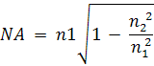

https://vlab.amrita.edu/userfiles/image058.png

The significance of NA is that light entering in the cone of semi vertical angle im only propagate through the fibre. The higher the value of im or NA more is the light collected for propagation in the fibre. Numerical aperture is thus considered as a light gathering capacity of an optical fibre.

Numerical Aperture is defined as the Sine of half  of the angle of fibre’s light acceptance cone.  i.e. NA= Sin θa where θa, is called acceptance cone angle.

Let the spot size of the beam at a distance d (distance between the fiber end and detector) as the radius of the spot(r). Then,

«math xmlns=¨http://www.w3.org/1998/Math/MathML¨»«mi mathvariant=¨normal¨»sin«/mi»«mi»§#952;«/mi»«mo»§nbsp;«/mo»«mo»=«/mo»«mo»§nbsp;«/mo»«mfrac»«mi»r«/mi»«msqrt»«mrow»«msup»«mi»r«/mi»«mn»2«/mn»«/msup»«mo»+«/mo»«msup»«mi»d«/mi»«mn»2«/mn»«/msup»«/mrow»«/msqrt»«/mfrac»«/math»     ------------------------ (4)

## Procedure for simulator **Controls**

**Start button:** To start the experiment.  
**Switch on**: To switch on the Laser.

**Select Fiber:** To select the type of fiber used.

**Select Laser:** To select a different laser source.

**Detector distance (Z)**: Use the slider to vary the distance between the source and detector. (ie toward the fiber or away from the fiber.

**Detector distance(x)**: Use the slider to change the detector distance i.e towards left or right w.r.t the fiber.

**Show Graph**: To Displays the graph.

**Reset**: To resets the experimental arrangement.

## Preliminary Adjustment

* Drag and drop each apparatus in to the optical table as shown in the figure below.

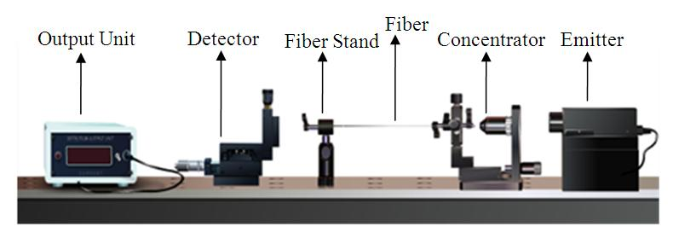

Fig (4)

* Then Click “Start” button.
* Switch On (now you can see a spot in the middle of the detector)
* After that select the Fiber and Laser for performing the experiment from the control options.

## To perform the experiment

* Set the detector distance Z (say 4mm). We referred the distance as “d” in our calculation.
* Vary the detector distance X by an order of 0.5mm, using the screw gauge (use up and down arrow on the screw gauge to rotate it).
* Measure the detector reading from output unit and tabulate it.
* Plot the graph between X in x-axis and output reading in y-axis.See figure 5.
* Find the radius of the spot r, which is corresponding to Imax/2.71

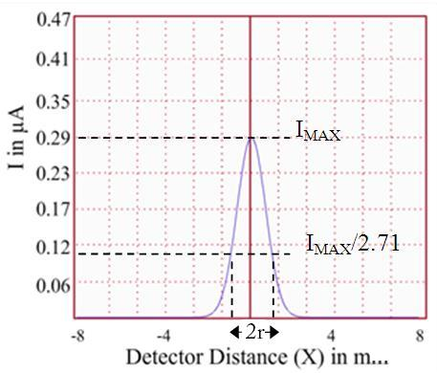

* Then find the numerical aperture of the optic fiber using the equation (4).

## Observations :

## Using Glass-glass Fiber 🡪

## 

## 

## Graph :

## 

## Using Plastic-Glass Fiber 🡪

## 

## Graph :

## 

## Calculations

Distance between the fiber and the detector, d = **5 mm**

Radius of the spot, r =**1.845 mm**

Numerical Aperture of the optic fiber,  sin(θ) = \frac{r}{\sqrt{r^{2}+d^{2}}}= **0.346**

Acceptance angle, θ= {sin^{-1}}\left ( \frac{r}{\sqrt{r^2+d^2}} \right ) =**20.250**

## 

## 

## Result

**Numerical aperture** of the **optic fiber** is =**0.346**

**Angle of acceptance** =**20.250**

**Virtual Lab Experiment 4**

Laser beam divergence and spot size

**Aim**

To calculate the beam divergence and spot size of the given laser beam.

### Laser

The term LASER is the acronym for Light Amplification by Stimulated Emission of Radiation. It is a mechanism for emitting electromagnetic radiation via the process of stimulated emission. The laser was the first device capable of amplifying light waves themselves. The emitted laser light is a spatially coherent, narrow low-divergence beam. When the waves(or photons) of a beam of light have the same frequency, phase and direction, it is said to be coherent . There are lasers that emit a broad spectrum of light, or emit different wavelengths of light simultaneously. According to the encyclopedia of laser physics and technology, beam divergence of a laser beam is a measure for how fast the beam expands far from the beam waist. A  laser beam with a narrow beam divergence is greatly used to make laser pointer devices. Generally, the beam divergence of laser beam is measured using beam profiler.

Lasers usually emit beams with a Gaussian profile. A Gaussian beam is a beam of electromagnetic radiation whose transverse electric field and intensity (irradiance) distributions are described by Gaussian functions.

For a Gaussian beam, the  amplitude of the complex electric field is given by

https://vlab.amrita.edu/userfiles/1/image/laser/laser1.JPG

 where,

r       - radial distance from the centre axis of the beam

z       - axial distance from the beam's narrowest point

i        - imaginary unit (for which i2 = − 1)

k       - wave number (in radians per meter).

w(z)    -radius at which the field amplitude drops to 1/e and field intensity to 1/e2 of their axial values, respectively.

w(0)  - waist size.

E0     =  |E( 0,0)|

R(z)- radius of curvature of the beam's wavefronts

ζ(*z*)- Gouy phase shift. It is an extra contribution to the phase that is seen in  beams which obey Gaussian profiles.

The corresponding time-averaged intensity (or irradiance) distribution is

https://vlab.amrita.edu/userfiles/1/image/laser/laser2.JPG

where I0 = I(0,0) is the intensity at the center of the beam at its waist. The constant «math xmlns=¨http://www.w3.org/1998/Math/MathML¨»«mi»§#951;«/mi»«/math» is defined as the characteristic impedance of the medium through which the beam is propagating.

For vacuum,

«math xmlns=¨http://www.w3.org/1998/Math/MathML¨»«mi»§#951;«/mi»«mo»=«/mo»«msub»«mi»§#951;«/mi»«mn»0«/mn»«/msub»«mo»§#8776;«/mo»«mn»377«/mn»«mo»§nbsp;«/mo»«mi»o«/mi»«mi»h«/mi»«mi»m«/mi»«/math»

### Beam parameters

Beam parameters govern the behaviour and geometry of a Gaussian beam. The important beam parameters are described below.

#### Beam divergence

The light emitted by a laser is confined to a rather narrow cone. But, when the beam propagates outward, it slowly diverges or fans out. For an electromagnetic beam, beam divergence is the angular measure of the increase in the radius or diameter with distance from the optical aperture as the beam emerges.

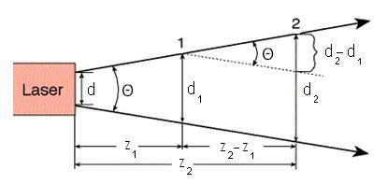

The divergence of a laser beam can be calculated if the beam diameter d1 and d2 at two separate distances are known. Let z1and z2 are the distances along the laser axis, from the end of the laser to points “1” and “2”.

Usually, divergence angle is taken as the full angle of opening of the beam. Then,

https://vlab.amrita.edu/userfiles/1/image/laser/laser4.JPG

Half of the divergence angle can be calculated as

https://vlab.amrita.edu/userfiles/1/image/laser/laser5.JPG

where w1 and w2 are the radii of the beam at z1 and z2.

Like all electromagnetic beams, lasers are subject to divergence, which is measured in milliradians (mrad) or degrees. For many applications, a lower-divergence beam is preferable.

#### Spot size

Spot size is nothing but the radius of the beam itself. The irradiance of the beam decreases gradually at the edges.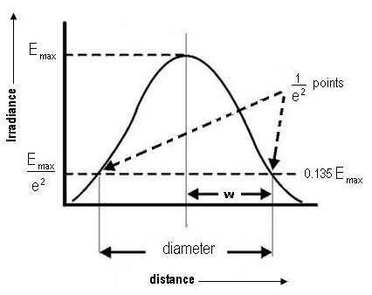

The distance across the center of the beam for which the irradiance (intensity) equals 1/e2 of the maximum irradiance (1/e2 = 0.135) is defined as the beam diameter. The spot size (w) of the beam is defined as the radial distance (radius) from the center point of maximum irradiance to the 1/e2 point.

Gaussian laser beams are said to be diffraction limited when their radial beam divergence  is close to the minimum possible value, which is given by

https://vlab.amrita.edu/userfiles/1/image/laser/9laser.JPG

where  λ is the wavelength of the given laser and *w0* is the radius of the beam at the narrowest point, which is termed as the beam waist.

### Performing the simulator:

* The experimental arrangement is shown in the simulator. A side view and top view of the set up is given in the inset.

* The **start** button enables the user to start the experiment.

* From the combo box, select the desired laser source.

* Then fix a detector distance, say 100 cm, using the slider **Detector distance, z**.

* The z distance can be varied from 50 cm to 200 cm.

* For a particular z distance, change the detector distance x, from minimum to maximum, using the slider **Detector distance, x**. The micrometer distances and the corresponding output currents are noted. The x distances can be read from the zoomed view of the micrometer and the current can be note from the digital display of the output device.

* Draw the graph and calculate the beam divergence and spot size using the steps given above.

* **Show graph** button enables the user to view the beam profile.

* Using the option **Show result**, one can verify the result obtained after doing the experiment.

**Observation Table**

|  |  |  |  |  |
| --- | --- | --- | --- | --- |
| **Detector Distance**  **Z(cm)** | **Detector Distance**  **X(mm)** | **Output Current**  **I(µA)** | **Divergence**  **α(mrad)** | **Spot Size**  **At Z(mm)** |
| 150 | 1.90 | 0.00028 | 0.40306 | 0.12192 |
| 150 | 1.95 | 0.01578 | 0.40306 | 0.12192 |
| 150 | 2.00 | 0.06061 | 0.40306 | 0.12192 |
| 150 | 2.05 | 0.01578 | 0.40306 | 0.12192 |
| 150 | 2.10 | 0.00028 | 0.40306 | 0.12192 |

**Screenshots**

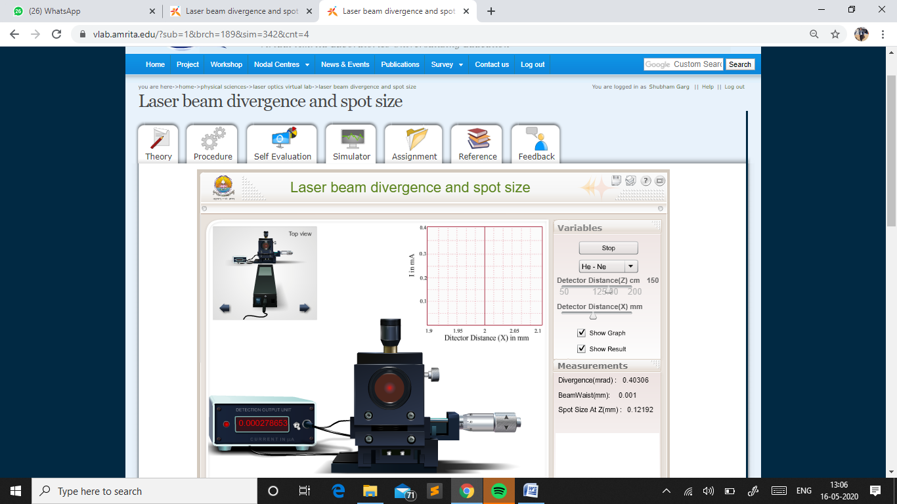

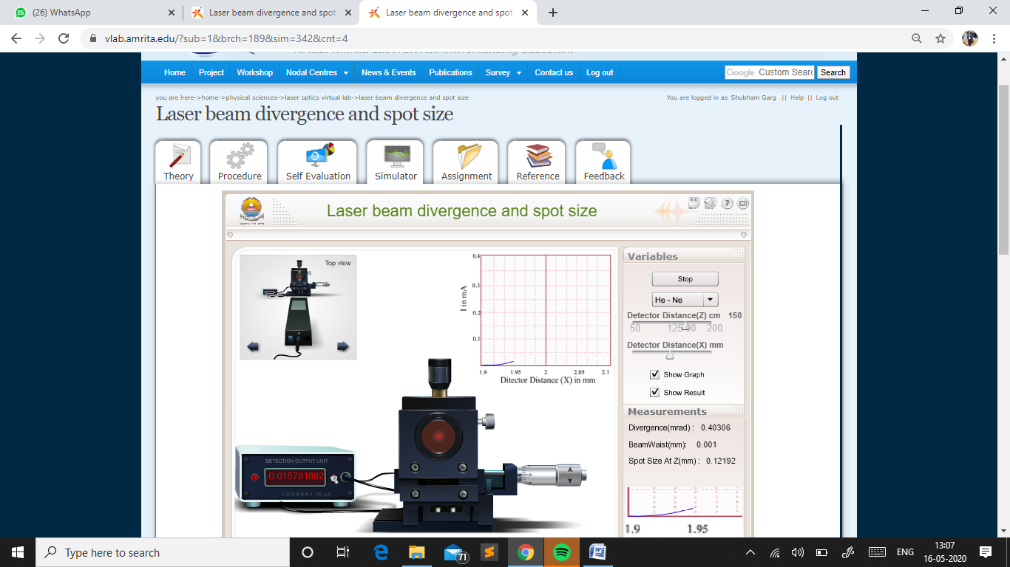

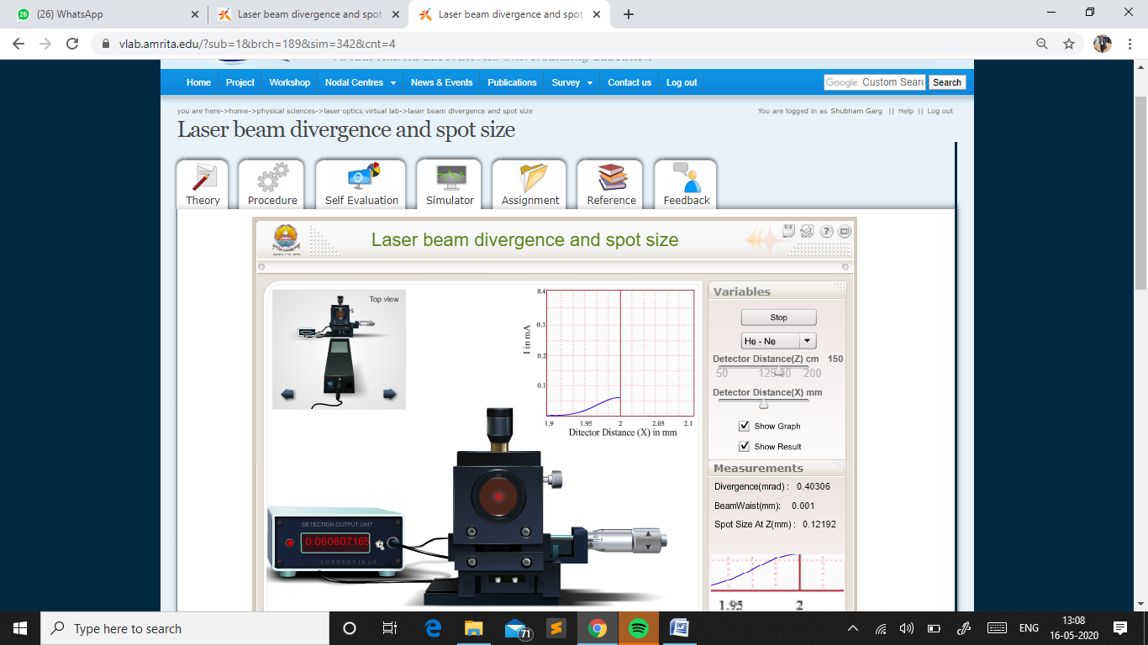

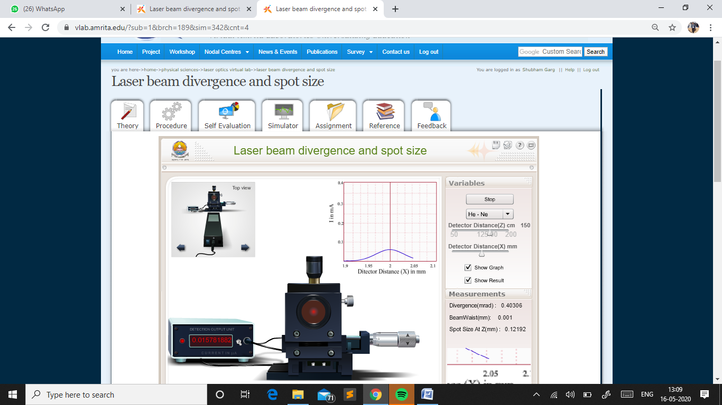

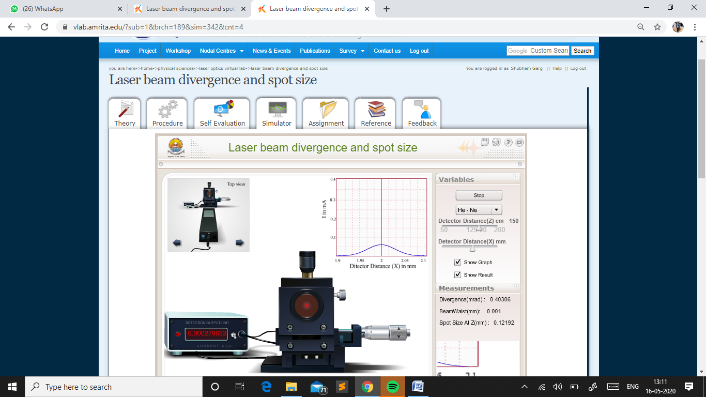

### Calculations

To find the Least Count of Screw gauge

One pitchscale division ( n) = **0.5 mm**

Number of divisions on head scale (m) = **50**

Least Count (L.C) = n/m = **0.01mm**

|  |  |
| --- | --- |
|  |  |
|  |  |
|  |  |

 Divergence angle(Θ) = (d2-d1)/(z2-z1) = **0.40306** **mrad**

|  |  |  |  |  |
| --- | --- | --- | --- | --- |
| **Detector Distance**  **Z(cm)** | **Detector Distance**  **X(mm)** | **Output Current**  **I(µA)** | **Divergence**  **α(mrad)** | **Spot Size**  **At Z(mm)** |
| 150 | 1.90 | 0.00028 | 0.40306 | 0.12192 |
| 150 | 1.95 | 0.01578 | 0.40306 | 0.12192 |
| 150 | 2.00 | 0.06061 | 0.40306 | 0.12192 |
| 150 | 2.05 | 0.01578 | 0.40306 | 0.12192 |
| 150 | 2.10 | 0.00028 | 0.40306 | 0.12192 |

**Graph**

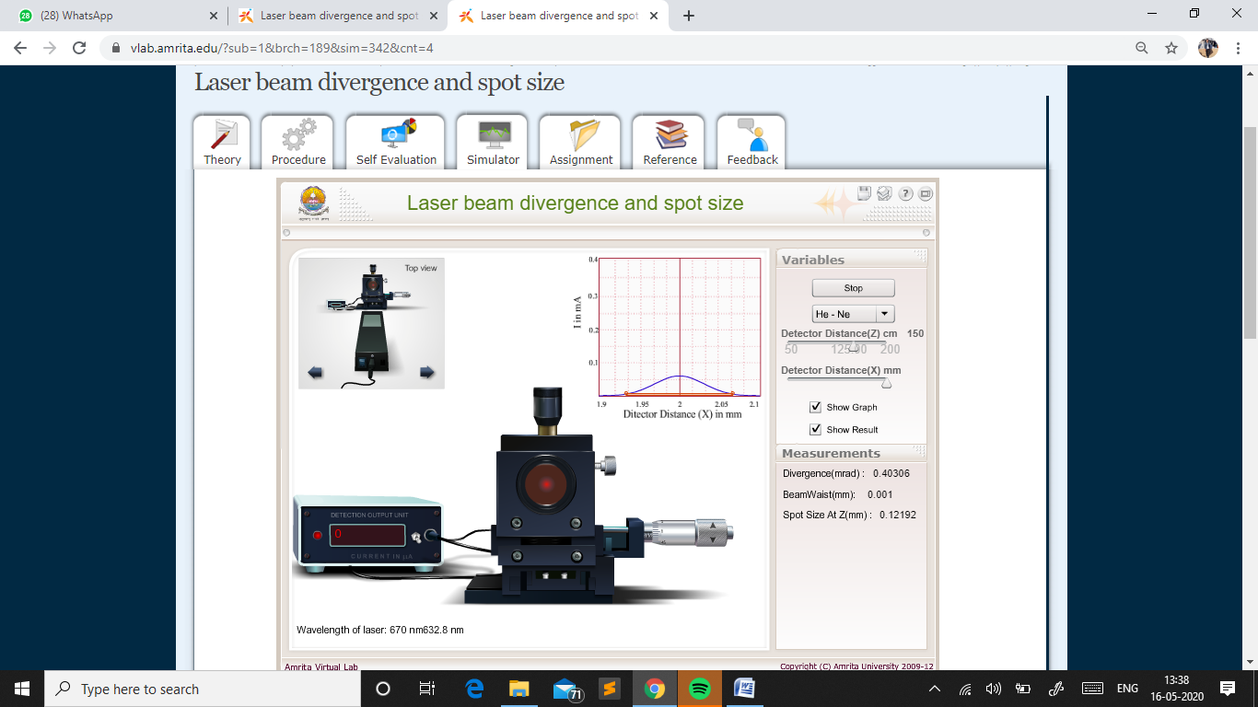

**Result**

The **Beam Divergence** of **He-Ne Laser** beam is **0.40306** **mrad**

The **Spot size** of the **He-Ne laser beam** at **Z=150cm** is **0.12192 mm**